Wits University Faculty of Science post-graduate student AI declaration
I understand that the use of generative AI tools (such as ChatGPT or similar) without explicitly declaring such use constitutes a form of plagiarism and is classified by Wits University as academic misconduct.
I declare that in the course of conducting the research towards my degree or in the preparation of this thesis/dissertation/research report (select one by marking with an X):

I did not make use of generative AI tools
I did make use of generative AI tools for the following (tick all that apply):
- Idea Generation (research problem/design, hypothesis)

- Sourcing Related Work (summarising, identifying sources)

- Methods and Experiment Design (experiment setup, model tuning)
- Data Analysis (presentation, coding, interpretation)

- Theoretical Development (theorem proving, conceptual analysis)

- Code Development (generating algorithms, writing scripts)

- Presentation (rendering graphics, formatting)

- Editing (grammar, readability)

- Writing (text generation, document structuring)

- Citation Formatting (structuring, organising)

If other uses were involved, please specify below:
Generative AI tool used (list all) | Used for?

If generative AI tools were used as an integral part of the experimental design or in the direct execution of my research, I confirm that details of this use are clearly outlined in the relevant experimental/methodology chapters of my thesis/dissertation/research report.
Student number: 2653934

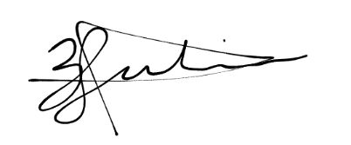
Candidate signature:

Date:

